Task 1 :
<!DOCTYPE html>
<html lang="en">
<head>
<meta charset="UTF-8">
<title>Home Page</title>
<style>
body {
font-family: "Times New Roman", serif;
margin: 40px;
}
h1, h2 {
font-weight: bold;
}

form {
margin-top: 20px;
}

label {
display: inline-block;
width: 80px;
margin-bottom: 10px;
}

input, textarea {
padding: 5px;
margin-bottom: 10px;
}

textarea {
width: 250px;
height: 60px;
}

button {
padding: 5px 10px;
}
</style>
</head>
<body >
<h1>Welcome to my website!</h1>
<p>This is the home page of my website.</p>
<h1>About Me</h1>
<p>My name is John Doe and I'm a web developer.</p>
<ol>
<li>HTML5</li>
<li>CSS3</li>
<li>JavaScript</li>
</ol>
<table>
<tr>
<td>Row 1, Column 1</td>
<td>Row 1, Column 2</td>
</tr>
<tr>
<td>Row 2, Column 1</td>
<td>Row 2, Column 2</td>
</tr>
</table>
<h1>Contact Me</h1>
<form>
<label>Name:</label>
<input type="text"><br>
<label>Email:</label>
<input type="email"><br>
<label>Message:</label>
<textarea></textarea><br>
<button type="submit">Send</button>
</form>
<p>Lorem ipsum dolor sit amet consectetur adipisicing elit. Accusantium ducimus impedit amet quibusdam itaque officia. Asperiores facilis quisquam neque omnis.</p>
<p>Lorem, ipsum dolor sit amet consectetur adipisicing elit. Quod dolores quidem nulla deserunt repudiandae necessitatibus.</p>
</body>
</html>
Screen Short of UI
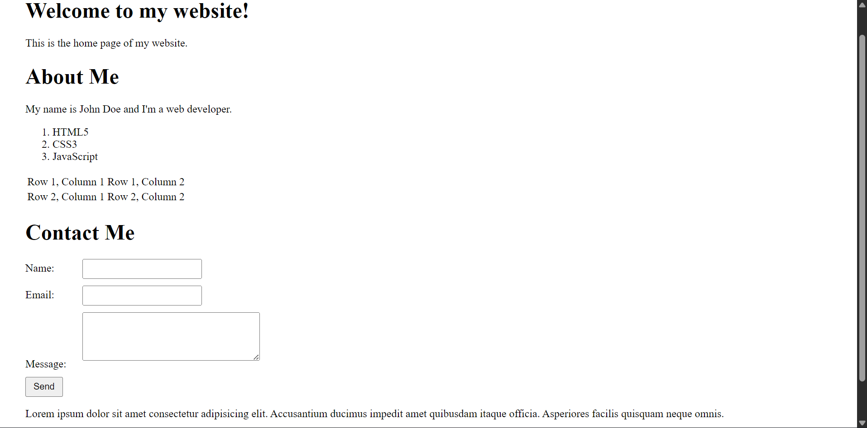
Task 2:
<!DOCTYPE html>
<html lang="en">
<head>
<meta charset="UTF-8">
<title>Menu Card</title>

<style>
body {
background-color: #111;
font-family: "Times New Roman", serif;
color: #f5c542;
}

.container {
width: 90%;
margin: auto;
border: 3px solid #555;
padding: 10px;
}

.title {
background: yellow;
color: black;
text-align: center;
font-size: 28px;
font-weight: bold;
padding: 5px;
border: 2px solid black;
}

.grid {
display: grid;
grid-template-columns: repeat(3, 1fr);
gap: 15px;
margin-top: 10px;
}

.card {
border: 2px solid #555;
padding: 5px;
}

.card h2 {
text-align: center;
border: 1px solid #555;
padding: 5px;
}

.card img {
width: 100%;
height: 150px;
object-fit: cover;
border: 1px solid #555;
}

table {
width: 100%;
border-collapse: collapse;
margin-top: 5px;
}

th, td {
border: 1px solid #555;
padding: 5px;
text-align: left;
}

th {
text-align: center;
}
.price {
text-align: right;
}
</style>
</head>
<body>
<div class="container">
<div class="title">MENUCARD</div>
<div class="grid">
<!-- PURE VEG -->
<div class="card">
<h2>PURE VEG</h2>
<img src="./p1.jpg" alt="">
<table>
<tr><th>Menu</th><th>Price</th></tr>
<tr><td>Mutter Paneer</td><td class="price">200</td></tr>
<tr><td>Shahi Paneer</td><td class="price">220</td></tr>
<tr><td>Kajoo Masala</td><td class="price">220</td></tr>
<tr><td>Palak Paneer</td><td class="price">180</td></tr>
<tr><td>Veg Kolhapuri</td><td class="price">160</td></tr>
<tr><td>Dal Tadka</td><td class="price">150</td></tr>
<tr><td>Bhendi Fry</td><td class="price">170</td></tr>
</table>
</div>
<!-- BREADS -->
<div class="card">
<h2>BREAD'S</h2>
<img src="./p2.jpg" alt="">
<table>
<tr><th>Menu</th><th>Price</th></tr>
<tr><td>Tanduri Roti</td><td class="price">20</td></tr>
<tr><td>Lachha Paratha</td><td class="price">30</td></tr>
<tr><td>Butter Naan</td><td class="price">25</td></tr>
<tr><td>Roomali Roti</td><td class="price">10</td></tr>
<tr><td>Aloo Paratha</td><td class="price">50</td></tr>
<tr><td>Plain Naan</td><td class="price">20</td></tr>
<tr><td>Garlic Naan</td><td class="price">30</td></tr>
</table>
</div>
<!-- NON VEG -->
<div class="card">
<h2>NON-VEG</h2>
<img src="./p3.jpg" alt="">
<table>
<tr><th>Menu</th><th>Price</th></tr>
<tr><td>Butter Chicken</td><td class="price">350</td></tr>
<tr><td>Kadai Chicken</td><td class="price">250</td></tr>
<tr><td>Chicken Curry</td><td class="price">300</td></tr>
<tr><td>Fish Curry</td><td class="price">400</td></tr>
<tr><td>Egg Curry</td><td class="price">150</td></tr>
<tr><td>Chicken Handi sp</td><td class="price">270</td></tr>
<tr><td>Prawns fry</td><td class="price">450</td></tr>
</table>
</div>
<!-- RICE -->
<div class="card">
<h2>RICE</h2>
<img src="./p4.jpg" alt="">
<table>
<tr><th>Menu</th><th>Price</th></tr>
<tr><td>Jeera Rice</td><td class="price">130</td></tr>
<tr><td>Veg Pulao</td><td class="price">130</td></tr>
<tr><td>Plain Rice</td><td class="price">90</td></tr>
<tr><td>Biryani</td><td class="price">150</td></tr>
<tr><td>Tawa Pulao</td><td class="price">100</td></tr>
<tr><td>Paneer Pulao</td><td class="price">140</td></tr>
<tr><td>Mutter Pulao</td><td class="price">140</td></tr>
<tr><td>Chicken Pulao</td><td class="price">210</td></tr>
</table>
</div>
<!-- CHINESE -->
<div class="card">
<h2>CHINESE</h2>
<img src="./p5.jpg" alt="">
<table>
<tr><th>Menu</th><th>Full</th><th>Half</th></tr>
<tr><td>Noodles</td><td>140</td><td>70</td></tr>
<tr><td>Manchurian</td><td>130</td><td>65</td></tr>
<tr><td>Fried Rice</td><td>100</td><td>50</td></tr>
<tr><td>Machew Soup</td><td>90</td><td>-</td></tr>
<tr><td>Szechwan Chilli</td><td>160</td><td>80</td></tr>
<tr><td>Szechwan Noodles</td><td>160</td><td>80</td></tr>
<tr><td>Szechwan Fried Rice</td><td>160</td><td>80</td></tr>
<tr><td>Chicken manchow soup</td><td>170</td><td>90</td></tr>
</table>
</div>
<!-- SOUTH INDIAN -->
<div class="card">
<h2>SOUTH - INDIAN</h2>
<img src="./p6" alt="">
<table>
<tr><th>Menu</th><th>Price</th></tr>
<tr><td>Plain Dosa</td><td class="price">35</td></tr>
<tr><td>Masala Dosa</td><td class="price">45</td></tr>
<tr><td>Vada Sambar</td><td class="price">40</td></tr>
<tr><td>Idli Sambar</td><td class="price">50</td></tr>
<tr><td>Pulihora</td><td class="price">110</td></tr>
<tr><td>Uttapa</td><td class="price">70</td></tr>
<tr><td>Loni-Spanj dosa</td><td class="price">60</td></tr>
<tr><td>Rasam - Rice</td><td class="price">50</td></tr>
</table>
</div>
</div>
</div>
</body>
</html>
Screen Short of UI
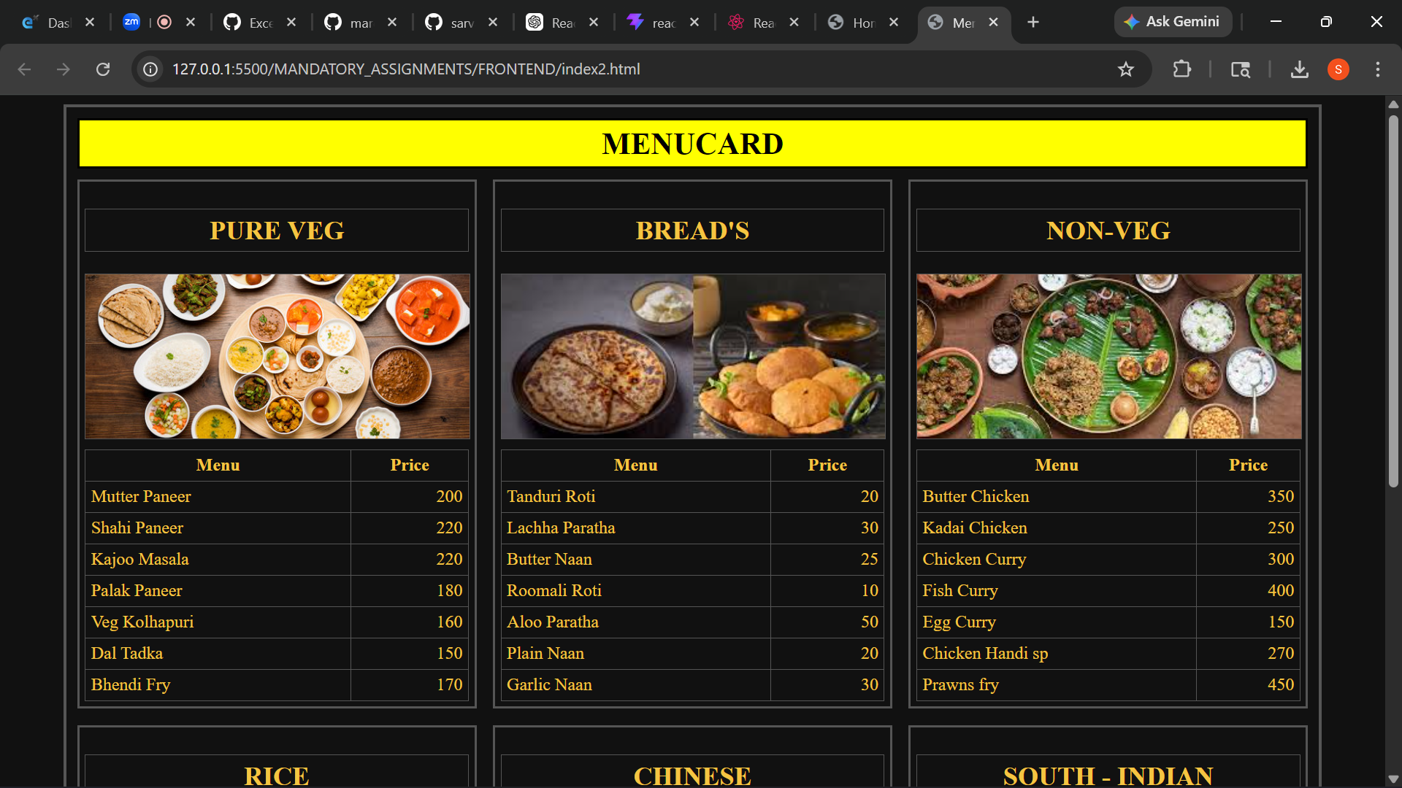
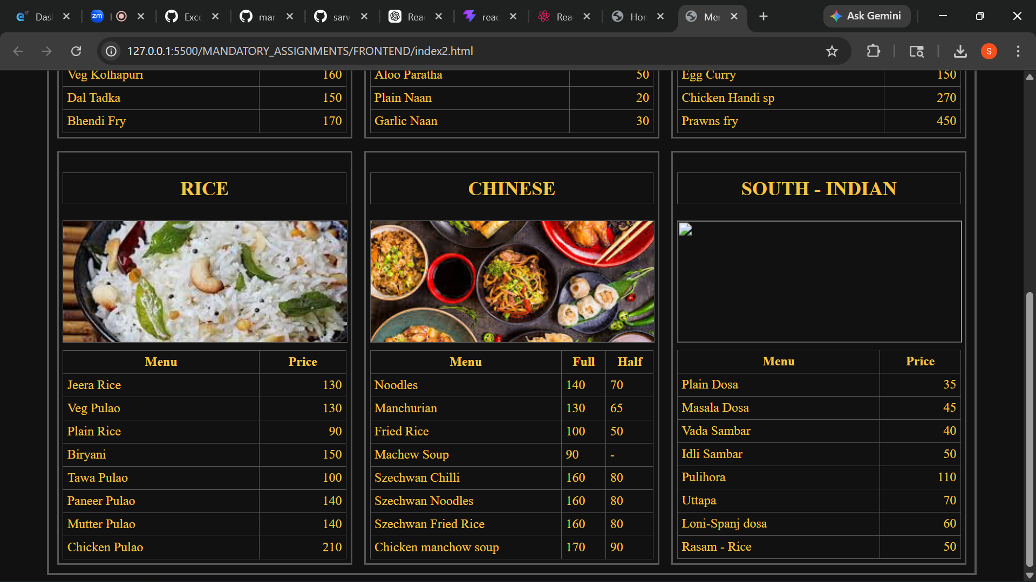
TASK 3 :
<!DOCTYPE html>
<html lang="en">
<head>
<meta charset="UTF-8">
<title>Form Input Controls Example</title>

<style>
body {
font-family: "Times New Roman", serif;
margin: 40px;
}

h1 {
text-align: center;
font-size: 40px;
}

form {
max-width: 900px;
margin: auto;
}

.row {
margin-bottom: 15px;
}

label {
margin-right: 10px;
}

input, select, textarea {
padding: 5px;
margin-right: 15px;
}

textarea {
width: 400px;
height: 100px;
display: block;
margin-top: 10px;
}

.inline {
display: inline-block;
margin-right: 20px;
}
</style>

</head>
<body>

<h1>Form Input Controls Example</h1>

<form>

<!-- Row 1 -->
<div class="row">
<label>Name:</label>
<input type="text" placeholder="Enter your name">

<label>Password:</label>
<input type="password" placeholder="Enter your password">

<label>Email:</label>
<input type="email" placeholder="Enter your email">
</div>

<!-- Row 2 -->
<div class="row">
<label>Age:</label>
<input type="number" value="18" style="width:60px;">

<label>Rating:</label>
<input type="range" min="0" max="10">

<label>Date of Birth:</label>
<input type="date">
</div>

<!-- Row 3 -->
<div class="row">
<label>Time:</label>
<input type="time">

<label>Image:</label>
<input type="file">
</div>

<!-- Row 4 -->
<div class="row">
<label>Week:</label>
<input type="week">
</div>

<!-- Row 5 -->
<div class="row">
<label>Month:</label>
<input type="month">
</div>

<!-- Row 6 -->
<div class="row">
<label>Datetime-Local:</label>
<input type="datetime-local">
</div>

<!-- Row 7 -->
<div class="row">
<label>URL:</label>
<input type="url" style="width:250px;">
</div>

<!-- Row 8 -->
<div class="row">
<label>Search:</label>
<input type="search" style="width:250px;">
</div>

<!-- Gender -->
<div class="row">
<label>Gender:</label><br>
<input type="radio" name="gender" checked> Male
<input type="radio" name="gender"> Female
</div>

<!-- Interests -->
<div class="row">
<label>Interests:</label><br>
<input type="checkbox"> Reading
<input type="checkbox" checked> Sports
</div>

<!-- Country -->
<div class="row">
<label>Country:</label>
<select>
<option>United States</option>
<option>India</option>
<option>UK</option>
</select>
</div>

<!-- Message -->
<div class="row">
<label>Message:</label>
<textarea placeholder="Enter your message"></textarea>
</div>

<!-- Submit -->
<div class="row">
<input type="submit" value="Submit">
</div>

</form>

</body>
</html>
SCREEN SHORT UI:
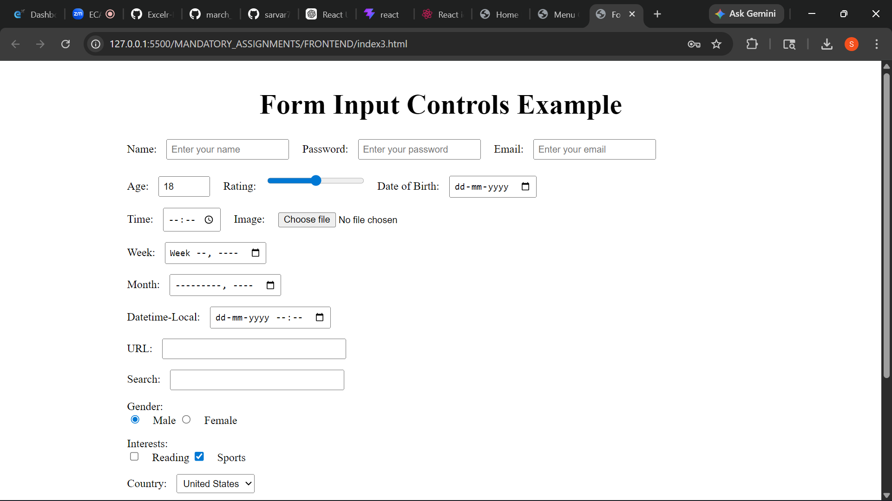
TASK 4:
<!DOCTYPE html>
<html lang="en">
<head>
<meta charset="UTF-8">
<title>Login Page</title>

<style>
body {
margin: 0;
font-family: Arial, sans-serif;
background: #f1f3f6;
}

/* Main container */
.container {
width: 800px;
height: 500px;
margin: 50px auto;
display: flex;
box-shadow: 0 4px 10px rgba(0,0,0,0.2);
}

/* Left section */
.left {
width: 40%;
background: #2874f0;
color: white;
padding: 40px 30px;
position: relative;
}

.left h1 {
margin-bottom: 20px;
}

.left p {
line-height: 1.5;
font-size: 15px;
}

/* Illustration (optional placeholder) */
.left img {
position: absolute;
bottom: 20px;
width: 80%;
}

/* Right section */
.right {
width: 60%;
background: white;
padding: 40px;
position: relative;
}

/* Input field */
.input-box {
margin-top: 20px;
}

.input-box input {
width: 100%;
border: none;
border-bottom: 1px solid #ccc;
padding: 10px 0;
font-size: 16px;
outline: none;
}

/* Terms text */
.terms {
font-size: 12px;
color: #878787;
margin-top: 20px;
}

.terms a {
color: #2874f0;
text-decoration: none;
}

/* Button */
.btn {
margin-top: 20px;
}

.btn button {
width: 100%;
background: #fb641b;
border: none;
color: white;
padding: 12px;
font-size: 16px;
cursor: pointer;
}

/* Bottom link */
.bottom-text {
position: absolute;
bottom: 20px;
left: 40px;
font-size: 14px;
}

.bottom-text a {
color: #2874f0;
text-decoration: none;
}
</style>

</head>

<body>

<div class="container">

<!-- Left Side -->
<div class="left">
<h1>Login</h1>
<p>Get access to your Orders, Wishlist and Recommendations</p>

<!-- Optional image -->
<img src="./logo_flip.png" alt="illustration">
</div>

<!-- Right Side -->
<div class="right">

<div class="input-box">
<input type="text" placeholder="Enter Email/Mobile number">
</div>

<div class="terms">
By continuing, you agree to Flipkart's
<a href="#">Terms of Use</a> and
<a href="#">Privacy Policy</a>
</div>

<div class="btn">
<button>Request OTP</button>
</div>

<div class="bottom-text">
New to Flipkart? <a href="#">Create an account</a>
</div>
</div>
</div>
</body>
</html>
SCREEN SHORT UI :

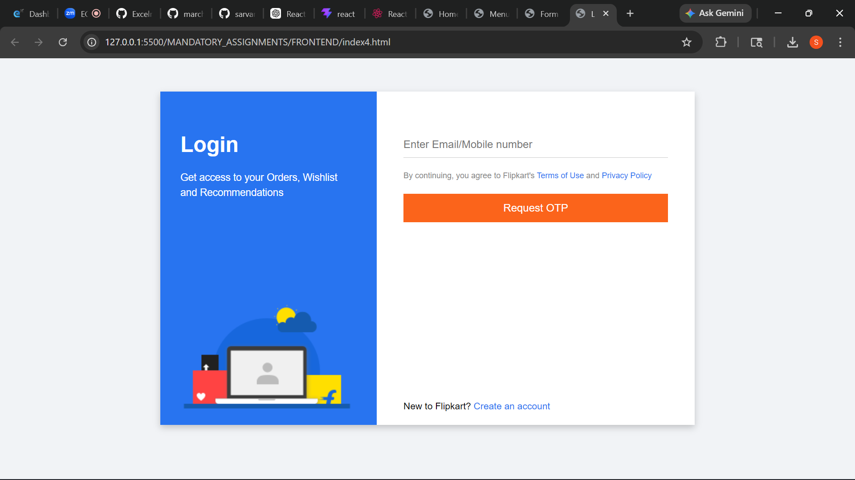
TASK 5 :

<!DOCTYPE html>
<html lang="en">
<head>
<meta charset="UTF-8">
<title>Box Layout</title>
<style>
body {
margin: 0;
height: 100vh;
display: flex;
flex-direction: column;
justify-content: center;
align-items: center;
background: linear-gradient(to bottom, pink, purple);
font-family: Arial, sans-serif;
}

.row {
display: flex;
justify-content: center;
margin: 20px 0;
}
.row_bottom{
display: flex;
justify-content: space-between;
gap: 90px;
}
.large-box {
width: 120px;
height: 120px;
background-color: gold;
border: 2px solid black;
margin: 10px;
display: flex;
flex-direction: column;
justify-content: space-between;
}

.small-boxes-top {
display: flex;
/* justify-content: start; */
}
._1{
justify-content: start;
}
._2{
justify-content: center;
}
._3{
justify-content: end;
}
._4,._6{
justify-content: space-around;
}
._5{
justify-content: space-between;
}
._9 ,._10 ,._11 ,._12{
display: flex;
}
._15{
display: flex;
align-items: start;
justify-content: center;
}
._12{
justify-content: flex-end;
}
._13{
justify-content: center;
align-items: center;
}
._14{
justify-content: flex-end;
align-items: center;
}
.small-box {
width: 30px;
height: 30px;
background-color: skyblue;
border: 1px solid black;
display: flex;
align-items: center;
justify-content: center;
font-size: 10px;
font-weight: bold;
}
</style>
</head>
<body>
<!-- Top row: 8 large boxes -->
<div class="row">
<!-- Repeat 8 times -->
<div class="large-box">
<div class="small-boxes-top _1">
<div class="small-box ">Box1</div>
<div class="small-box ">Box2</div>
<div class="small-box">Box3</div>
</div>
</div>
<div class="large-box">
<div class="small-boxes-top _2">
<div class="small-box ">Box1</div>
<div class="small-box ">Box2</div>
<div class="small-box ">Box3</div>
</div>
</div>
<div class="large-box">
<div class="small-boxes-top _3">
<div class="small-box ">Box1</div>
<div class="small-box ">Box2</div>
<div class="small-box ">Box3</div>
</div>
</div>
<div class="large-box">
<div class="small-boxes-top _4">
<div class="small-box ">Box1</div>
<div class="small-box ">Box2</div>
<div class="small-box ">Box3</div>
</div>
</div>
<div class="large-box">
<div class="small-boxes-top _5">
<div class="small-box ">Box1</div>
<div class="small-box ">Box2</div>
<div class="small-box ">Box3</div>
</div>
</div>
<div class="large-box">
<div class="small-boxes-top _6">
<div class="small-box ">Box1</div>
<div class="small-box ">Box2</div>
<div class="small-box ">Box3</div>
</div>
</div>
<div class="large-box">
<div class="small-boxes-top _7">
<div class="small-box ">Box1</div>
<div class="small-box ">Box2</div>
<div class="small-box ">Box3</div>
</div>
</div>
</div>
<!-- Bottom row: 4 large boxes -->
<div class="row_bottom">
<!-- Repeat 4 times -->
<div class="large-box _15">
<div class="small-boxes-bottom _9">
<div class="small-box ">Box1</div>
<div class="small-box">Box2</div>
<div class="small-box">Box3</div>
</div>
</div>
<div class="large-box _12">
<div class="small-boxes-bottom _10">
<div class="small-box ">Box1</div>
<div class="small-box ">Box2</div>
<div class="small-box ">Box3</div>
</div>
</div>
<div class="large-box _13">
<div class="small-boxes-bottom _11">
<div class="small-box ">Box1</div>
<div class="small-box ">Box2</div>
<div class="small-box ">Box3</div>
</div>
</div>
<div class="large-box _14">
<div class="small-boxes-bottom _12">
<div class="small-box ">Box1</div>
<div class="small-box ">Box2</div>
<div class="small-box ">Box3</div>
</div>
</div>
</div>
</body>
</html>

SCREEN SHORT UI :

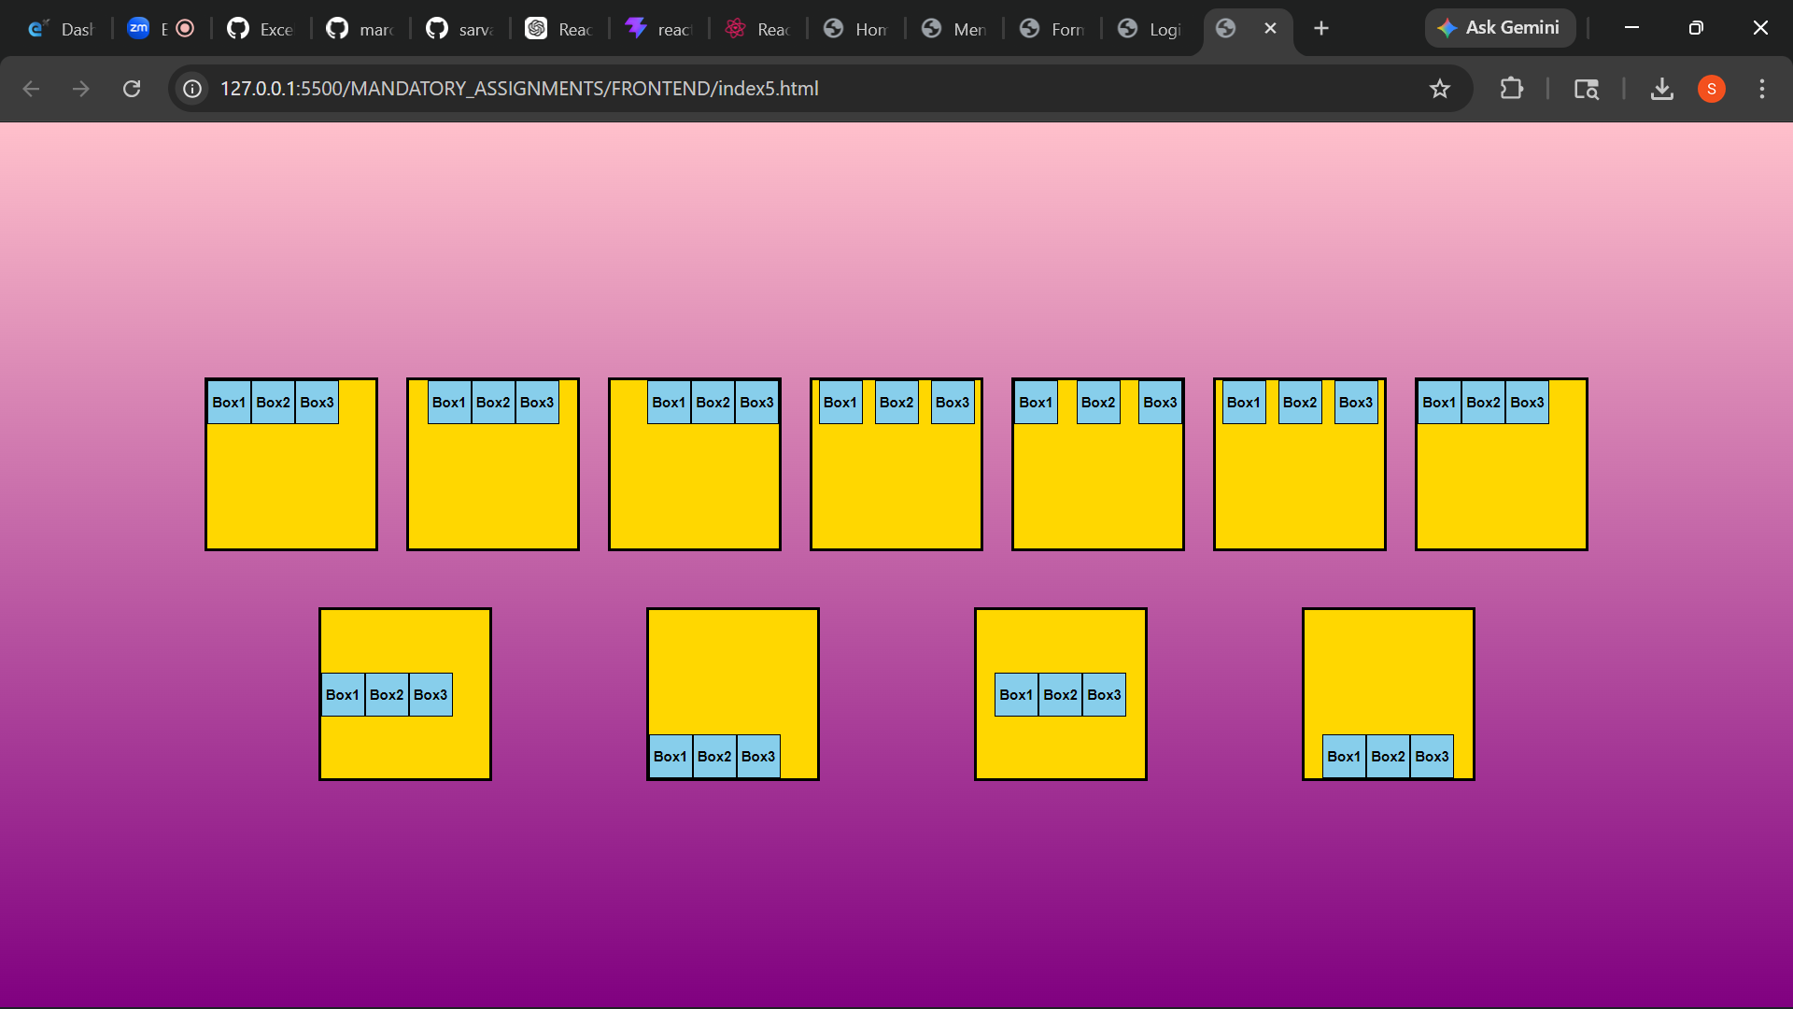

TASK 6 :
<!DOCTYPE html>
<html lang="en">
<head>
<meta charset="UTF-8">
<title>Website Layout using CSS Grid</title>
<style>
body {
margin: 0;
font-family: Arial, sans-serif;
}
.container {
display: grid;
grid-template-areas:
"header header"
"sidebar main"
"footer footer";
grid-template-columns: 200px 1fr;
grid-template-rows: 80px 1fr 60px;
height: 100vh;
}
header {
grid-area: header;
background-color: #333;
color: white;
display: flex;
align-items: center;
justify-content: center;
font-size: 1.5em;
}
aside {
grid-area: sidebar;
background-color: #ddd;
padding: 20px;
}
main {
grid-area: main;
background-color: #fff;
padding: 20px;
}
footer {
grid-area: footer;
background-color: #333;
color: white;
display: flex;
align-items: center;
justify-content: center;
}
</style>
</head>
<body>
<div class="container">
<header>Header</header>
<aside>
<h3>Sidebar</h3>
<p>The Menu or quick access content.</p>
</aside>
<main>
<h3>Main Content</h3>
<p>The core website content should be displayed here.</p>
</main>
<footer>Footer</footer>
</div>
</body>
</html>
SCREEN SHORT UI :
